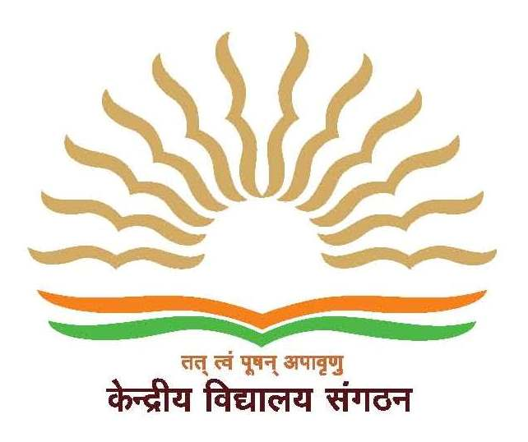
केन्द्रीय विद्यालय नं १ सॅाल्‍टलेक
KENDRIYA VIDYALAYA NO.1, SALT LAKE
ई. बी. ब्‍लॅाक, लावोनी, सेक्‍टर १, EB BLOCK, LABONI, SECTOR-1, SALTLAKE
कोलकाता – ७०००६४ पश्चिम बंगाल KOLKATA-700 064 West-Bengal
शिक्षा मंत्रालय, भारत सरकार के अधीनस्‍थ् Under the Ministry of Education, Govt. Of India
KVS Region Code: 06, School Code: 1272, Website: https://no1saltlake.kvs.ac.in
CBSE School No. 19229, CBSE Affiliation No. 2400002
E-Mail:kv1saltlake@gmail.com, Phone O33-23212767/ 23212767

Notice for contractual appointments for 2023-24

Applications are invited from eligible candidates for contractual appointment for different posts as mentioned below for the session 2023-24 for KV1 Salt Lake and KV2 Salt Lake.

Post for which interview will be conducted | Interview Venue
TGT (Hindi, English,Math,Science,Sanskrit, Social Science)  PGT(Hindi, English, Physics, Chemistry, Maths, Biology , Biotech , History,Geography,Pol.Sc. Economics, Commerce.) | KV No. 1 Salt Lake
PRT, PGT(Comp. Sc.) , Computer Instructor for Primary & Secondary , Doctor , nurse , Counsellor, Special Educator , Yoga Teacher , Sports Coach , Dance / Music Coach. | KV No. 2 Salt Lake

Interested candidates can fill up through following link
https://docs.google.com/forms/d/e/1FAIpQLScqhHuqNGiP52TuAYD4-J5gV5-34p31dCNJb6syh0v0CkXBdg/viewform?usp=sf_link
Exact date for interview for different posts will be published on website shortly https://no1saltlake.kvs.ac.in/ and https://no2saltlake.kvs.ac.in/ . Candidates are requested to visit these sites regularly for same

Last Date for applying: 12/03/2023
By order

